<meta name=”keywords” content=”keywords”>

This tag is used to define keywords

Example:

<meta name=”keywords” content=”java,oracle,HTML”>

<meta name=”description” content=”description”>

This tag is used to provide information about web page or web site.

Example:

<meta name=”description” content=”Best Training for HTML, CSS, JS, JAVA, PYTHON in Hyderabad”>

**<style>…</style>**

This tag is used for defining CSS styles

<style>

</style>

**<script>…</script>**

It is used to insert or embed java script code

<script>

Java script coding

</script>

**body**

The content of web page is defined inside body tag.

The content is displayed within browser as a part of web page.

**Syntax:**

<body>

</body>

In HTML4 version layout of the webpage or body is defined using tables. The problem with tables is, the content is loaded randomly.

In HTML 5 version they introduced semantic elements. The elements which are used for specific purpose are called semantic elements.

In HTML5 there are more than 100 semantic elements. These semantic elements are introduced to make your web page SEO friendly.

**Example:**

<header>

<footer>

<section>

<summary>

<nav>

<figure>

<time>

Etc…

**Non semantic tags or elements**

The elements which can be used for any purpose are called non semantic tags or elements.

1. <div>
2. <span>

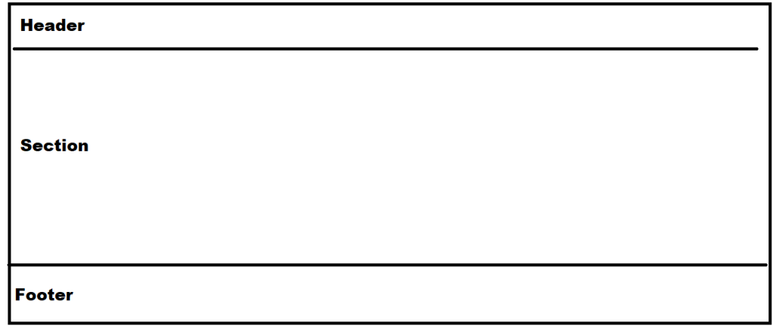

**<div>**

**<div>** is non semantic tag, it is used to organize related content by dividing into divisions.

**<span>**

This tag is used or embedded within line of text or continues text or elements.

**Example:**

<!DOCTYPE *html*>

<html *lang*="en">

<head>

    <meta *charset*="UTF-8">

    <meta *name*="viewport" *content*="width=device-width, initial-scale=1.0">

    <title>Layout Demo</title>

    <style>

        div{

            border: 2px black solid;

            margin: 10px;

            padding: 5px;

        }

        span

        {

            color:blue;

        }

    </style>

</head>

<body>

    <div>

        Full Stack Python

        <div>

            Module-1 Python

            <div>

                Core Python

                <div>

                    Python <span>Language</span> Fundamentals

                </div>

            </div>

            <div>

                Adv Python

                <div>

                    OOP, Database, Exceptions<br>

                    Files, GUI, Date Time

                </div>

            </div>

        </div>

        <div>

            Module-2 FrontEnd

            <div>

                HTML

                <div>

                    Creating Web Pages

                </div>

                <div>

                    CSS

                    <div>

                        Styling Web Pages

                    </div>

                </div>

            </div>

        </div>

    </div>

</body>

</html>

**Attributes of body tag**

codewithsatishgupta